

##### Informatics Institute of Technology

##### Course: Foundation Certificate Programme.

##### Unit Code and Description: DOC 333, Introduction to Programming in Python.

##### Module Leader: Mr. Sudharshan Welihinda.

##### Assignment Number: 1

##### Assignment Type: Individual

##### Issue Date: 9th March 2021.

##### Hand – in – Date: 2nd April 2021.

##### Deadline: on or before 9.00 AM.

##### Student Name: S.Mohanaranjan.

##### Student ID: 20200607

# Acknowledgement

I would like to express my gratitude to all of my lecturers Mr.Sudharshana Welihindha and tutors Ms. Salitha Dinushika and Ms.Tharushi Sandamali Amarasinghe, colleagues and our institute Informatics institute of Technology, for completing my report and specially to lovable parents and my family members for their unwavering support. I would like to express my gratitude to all those who helped in many ways to complete this assignment.

Thank You!

Table of Contents

Acknowledgement 2

List of Figures 3

List of Tables 3

Question : 1 4

Problem : 4

Problem Understanding : 4

Algorithm : 4

Python Code : 5

Question : 2 10

Problem : 10

Problem Understanding : 10

Algorithm : 10

Python Code : 11

Question : 3 15

Problem : 15

Problem Understanding : 15

Algorithm : 15

Python Code : 16

Conclusion 19

# List of Figures

Figure 1 : Question 1 pic 1 8

Figure 2 : Question 1 pic 2 9

Figure 3 : Question 2 pic 1 13

Figure 4 : Question 2 pic 2 14

Figure 5 : Question 3 18

# List of Tables

Table 1 : Question 1 6

Table 2 : Question 2 12

Table 3 : Question 3 17

# Question : 1

## Problem :

Select the cyclists through the Medical test and Run in the track minimum of ten rounds for the Cycle Race.

## Problem Understanding :

In a cycle race, the participating cyclists are required to qualify from the preliminary stage into the final stage. First passing a medical test and then by completing ten rounds in a circular track. Those who do not pass the medical test will not be allowed to attempt ten rounds in the track. Those who complete ten rounds in the track are eligible to participate in the final stage. Others who get tired and are unable to complete ten rounds in the track are eliminated from the contest.

## Algorithm :

Step 1 : Start

Step 2 : Initialize variables test and count

Step 3 : input test pass or not

Step 4 : If user gets the pass of medical test he can go for the ten rounds on track,

Else he not allowed to attempts the ten rounds on the track.

Step 5 : Input count of the rounds run.

Step 6 : If he went for ten rounds then he completed ten rounds only eligible for Cycle Race,

Else the user cannot eligible final stage of Cycle Race.

Step 7 : End.

# Python Code :

#----------- Question 01. ----------------------------------------------------------------------------------

#-------- Qualify from the preliminary stage into the final stage for the Cycle Race. -----------

#---- Create and Initialize the variables. ----------------------------------------------------------------

test=0

count=0

#----------- Input data of the medical test. ---------------------------------------------------------------

test=int(input("Are you passed the Medical Test? (1/0): "))

if(test==1):

print("Eligible to go for the ten rounds")

#--- Input completed rounds. ----------------------------------------------------------------------------

count=int(input("How many rounds you completed in Ten(10) rounds? : "))

if (count>=10):

print("Best Regards, \nYou are qualify from preliminary stage into the final stage \nand eligible to the Cycle Race.")

elif (count<10):

print("Sorry, \nyou are not eligible for the final stage \nBetter try Next time.")

elif(test==0):

print("Not allowed to attempt the ten rounds in the track")

elif(test==2 or 3 or 4 or 5 or 6 or 7 or 8 or 9) :

print("if you are not took the medical test, \nYou can go and take it otherwise Not qualify for the ten rounds")

#----------------------------------------- End of a programme --------------------------------------------

Table 1 : Question 1

|  |  |  |  |  |  |
| --- | --- | --- | --- | --- | --- |
| Test Case # | Inputs | | Expected Output | Actual Output | Remarks |
|  | Test | Count |  |  |  |
| 1 | 1 | 10 | Eligible to go for the ten rounds  How many rounds you completed in Ten(10) rounds? : 10  Best Regards,  You are qualify from preliminary stage into the final stage  and eligible to the Cycle Race. | Eligible to go for the ten rounds  How many rounds you completed in Ten(10) rounds? : 10  Best Regards,  You are qualify from preliminary stage into the final stage  and eligible to the Cycle Race. | Test Case Pass |
| 2 | 0 |  | Not allowed to attempt the ten rounds in the track | Not allowed to attempt the ten rounds in the track | Test Case Pass |
| 3 | 1 | 6 | Eligible to go for the ten rounds  How many rounds you completed in Ten(10) rounds? : 6  Sorry,  you are not eligible for the final stage  Better try Next time. | Eligible to go for the ten rounds  How many rounds you completed in Ten(10) rounds? : 6  Sorry,  you are not eligible for the final stage  Better try Next time. | Test Case Pass |
| 4 | 1 | 13 | Eligible to go for the ten rounds  How many rounds you completed in Ten(10) rounds? : 13  Best Regards,  You are qualify from preliminary stage into the final stage  and eligible to the Cycle Race. | Eligible to go for the ten rounds  How many rounds you completed in Ten(10) rounds? : 13  Best Regards,  You are qualify from preliminary stage into the final stage  and eligible to the Cycle Race. | Test Case Pass |
| 5 | 1 | 20 | Eligible to go for the ten rounds  How many rounds you completed in Ten(10) rounds? : 20  Best Regards,  You are qualify from preliminary stage into the final stage  and eligible to the Cycle Race. | Eligible to go for the ten rounds  How many rounds you completed in Ten(10) rounds? : 20  Best Regards,  You are qualify from preliminary stage into the final stage  and eligible to the Cycle Race. | Test Case Pass |

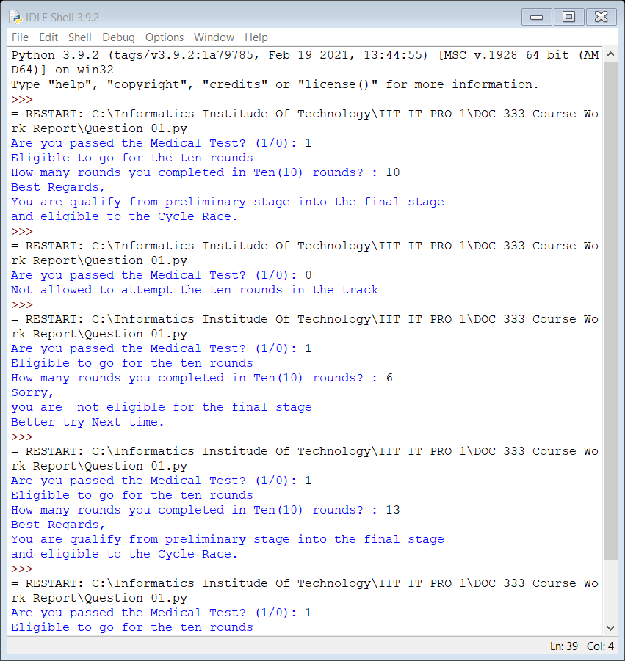

Figure 1 : Question 1 pic 1

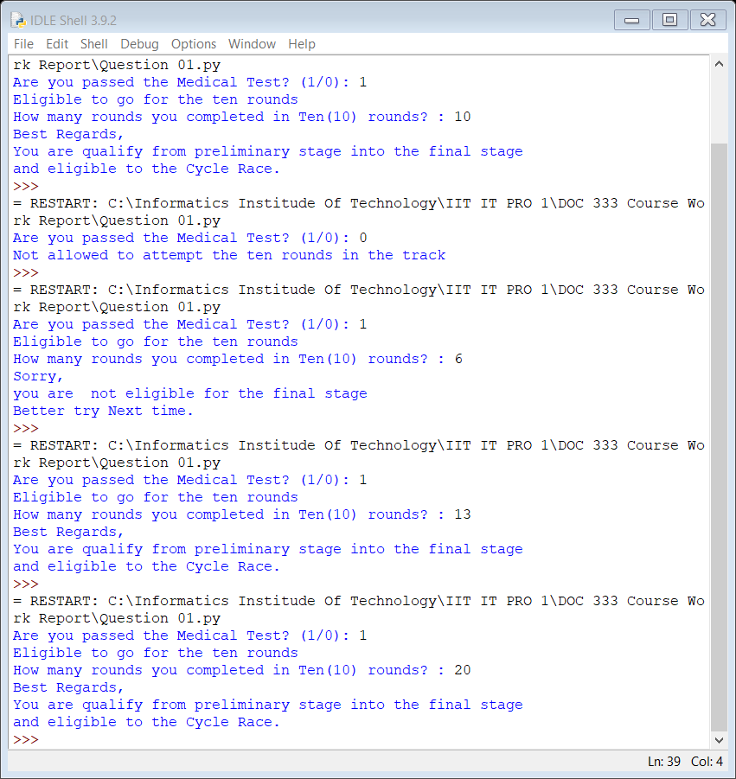

Figure 2 : Question 1 pic 2

# Question : 2

## Problem :

Design a program to calculate the Base area, Surface area and Volume of a cone while input the Radius, Height and Slant height from user. Then it has option to display one answer or all the Base area, Surface area and Volume of a cone.

## Problem Understanding :

Design and develop Python program reads the Radius Height and Slant height of a cone. User can type in the radius, height and slant height. When user inputs **A** as an option, the program calculate and display the Surface Area, Volume and Base Area of the cone using the formulas. Similarly input **S**-Surface Area, **V**-Volume and **B**-Base Area can be calculate and display the value of them. Values are blank program display an error message.

## Algorithm :

Step 1 : Start

Step 2 : Initialize variables radius(r), height(h), slant height(l) and Option.

Step 3 : Input radius(r), height(h), slant height(l) and Option

Step 4 : bac=pi*r*r

Step 5 : sac=(pi*r*r) + (pi*r*l)

Step 6 : vc=(1/3) * (pi*r*r) * (h)

Step 7 :if option **A** then print all bac, sac and vc.

Step 8 : if option **S** then print (sac).

Step 9 : if option **V** then print (vc).

Step 10 : if option **B** then print (bac). Else print “invalid option”.

Step 11 : End.

# Python Code :

#---------- Question 02. -------------------------------------------

#----- Display surface area, volume and base area of the cone. -----

#------- Creating and Initializing variables. ----------------------

r=0

h=0

l=0

bac=0

sac=0

vc=0

option=""

pi=3.14

#------ Input Values for the calculation. --------------------------

print("Input the Radius(r),Height(h) and Slant Height(l) in same unit(m or cm) only.")

r=float(input("Radius(r) : "))

h=int(input("Height(h) : "))

l=int(input("Slant Height(l) : "))

option=input("Type an Option(A/S/V/B)Required : ")

#----Calculating for the Surface Area(sac),Volume(vc)and Base Area(bac)of cone. -----

bac=(pi*r**2)

sac=(pi*r**2) + (pi*r*l)

vc=(1/3) * (pi*r**2) * h

#---- Display the Surface Area, Volume and Base Area. -------------

if (option=="A"):

print("Base Area of a Cone : ",bac)

print("Surface Area of a Cone : ",sac)

print("Volume of a Cone : ",vc)

elif(option=="S"):

print("Surface Arae of a Cone : ",sac)

elif(option=="V"):

print("Volume of a Cone : ",vc)

elif(option=="B"):

print("Base Area of a Cone : ",bac)

else:

print("Invalid Option")

#------------------------ End of programme ------------------------

Table 2 : Question 2

|  |  |  |  |  |  |  |  |
| --- | --- | --- | --- | --- | --- | --- | --- |
| Test Case # | Inputs | | | | Expected Output | Actual Output | Remarks |
|  | Radius | Height | Slant height | Option |  |  | Test Case Pass |
| 1 | 40 | 50 | 60 | A | Base Area of a Cone : 5024.0  Surface Area of a Cone : 12560.0  Volume of a Cone : 83733.3 | Base Area of a Cone : 5024.0  Surface Area of a Cone : 12560.0  Volume of a Cone : 83733.3 | Test Case Pass |
| 2 | 23 | 34 | 40 | S | Surface Area of a Cone : 4549.860000000001 | Surface Area of a Cone : 4549.860000000001 | Test Case Pass |
| 3 | 30.3 | 43 | 57 | V | Volume of a Cone : 41320.170600000005 | Volume of a Cone : 41320.170600000005 | Test Case Pass |
| 4 | 7.5 | 8 | 11 | B | Base Area of a Cone : 176.625 | Base Area of a Cone : 176.625 | Test Case Pass |
| 5 | 4 | 3 | 5 | Q | Invalid Option | Invalid Option | Test Case Pass |

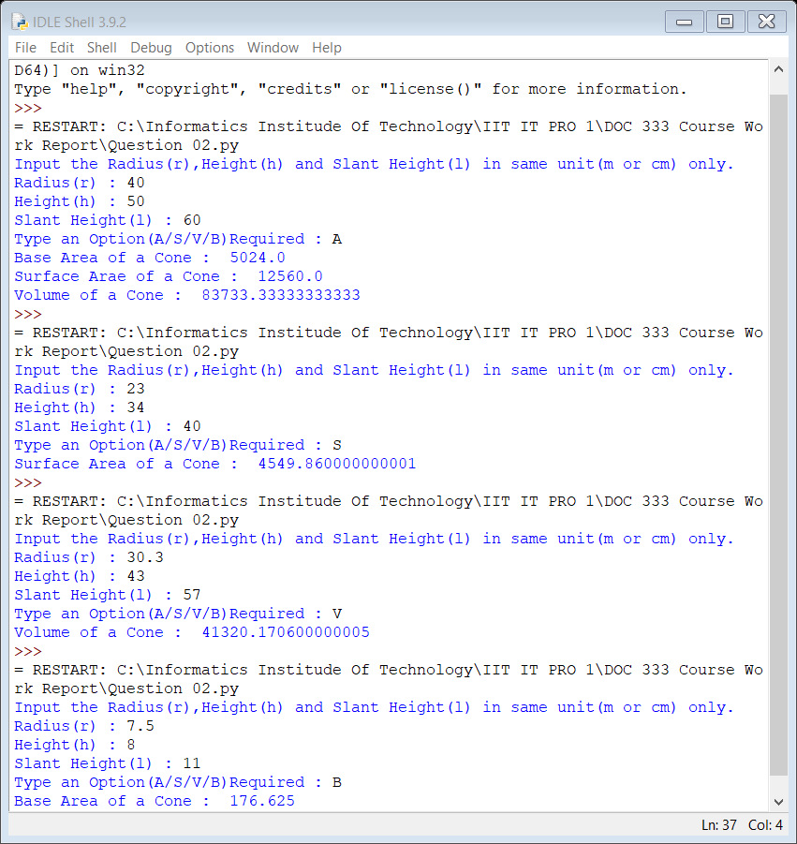

Figure 3 : Question 2 pic 1

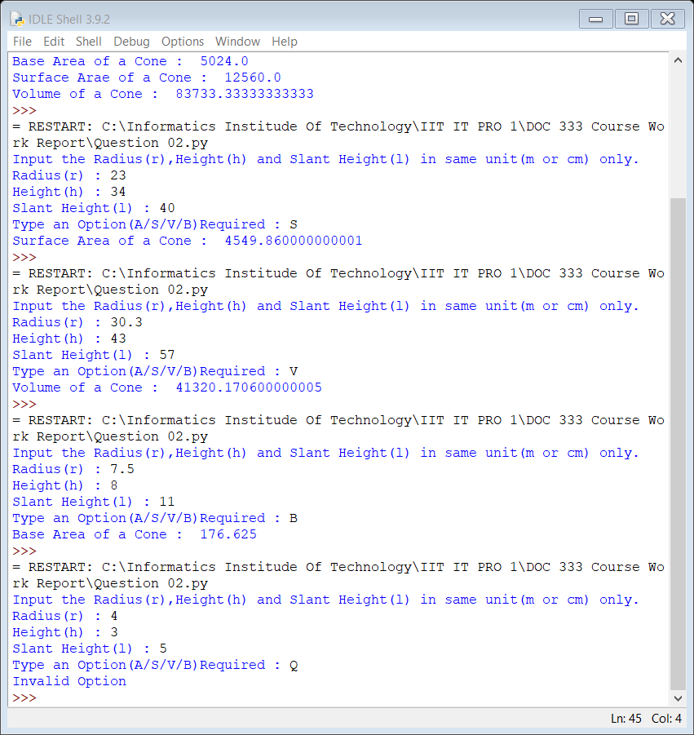

Figure 4 : Question 2 pic 2

# Question : 3

## Problem :

Create program to calculate Body Mass Index. Get the weight in kilograms and height in meters of the user, then calculates and displays the body mass index.

## Problem Understanding :

The user inputs the weight in kilograms and height in meters. Then calculates and displays the user body mass index through the formulae. It displays the respective condition of body related to BMI.

BMI VALUES

Underweight: less than 18.5

Normal: between 18.5 and 24.9

Overweight: between 25 and 29.9

Obese: 30 or greater

## Algorithm :

Step 1 : Start.

Step 2 : Create and Initialize variables height,weight,bmi=0.

Step 3 : Input Height (m)and Weight(kg).

Step 4 : bmi=weight/(height*height)

Step 5 : if bmi<18.5 then print “Under Weight” .

Step 6 : if 18.5<bmi<24.9 then print “Normal”.

Step 7 : if 25<bmi<29 then print “Over Weight”.

Step 8 : if 30<bmi then print “Obese”.

Step 9 : End.

# Python Code :

#-------- Question 03. -----------------------------------------

#------ Evaluate the Body Mass Index(BMI). ---------------------

#-------------- Creating and Initializing variables. -----------

bmi=0

height=0

weight=0

#-------------- Input the Height(m) and Weight(kg) -------------

weight=float(input("Enter the Weight in kilograms : "))

height=float(input("Enter the Height in meters : "))

#------------ Calculating BMI ----------------------------------

bmi=weight/(height*height)

# ------ Display BMI -------------------------------------------

print("Body Mass Index :%0.2f"%bmi)

if (bmi<18.5):

print("Under Weight")

elif (18.5<bmi<24.9):

print("Normal")

elif (25<bmi<29):

print("Over Weight")

elif (30<bmi):

print("Obese")

#-------------- End of a programme --------------------------

Table 3 : Question 3

|  |  |  |  |  |  |
| --- | --- | --- | --- | --- | --- |
| Test Case # | Inputs | | Expected Output | Actual Output | Remarks |
|  | Weight | Height |  |  |  |
| 1 | 55 | 1.5 | Body Mass Index :24.44  Normal | Body Mass Index :24.44  Normal | Test Case Pass |
| 2 | 50 | 1.4 | Body Mass Index :25.51  Over Weight | Body Mass Index :25.51  Over Weight | Test Case Pass |
| 3 | 100 | 1.72 | Body Mass Index :33.80  Obese | Body Mass Index :33.80  Obese | Test Case Pass |
| 4 | 50 | 1.7 | Body Mass Index :17.30  Under Weight | Body Mass Index :17.30  Under Weight | Test Case Pass |
| 5 | 60 | 1.68 | Body Mass Index :21.26  Normal | Body Mass Index :21.26  Normal | Test Case Pass |

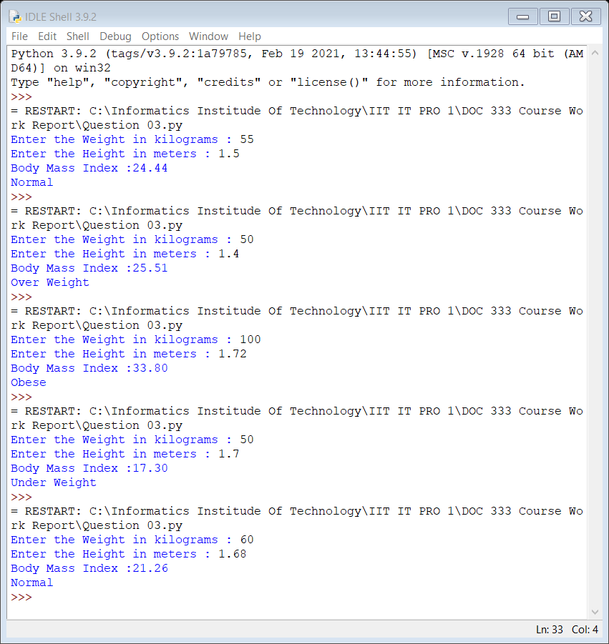

Figure 5 : Question 3

Conclusion

At the end of the report can understand some kind of problems and methods to solve them through the python. It would helped to beginner of coding users while the other kinds of application software used among the software developers in coding.

These are some of the examples of coding to a problem. This may develop in a different way in the future.